Landscape Weathering and Erosion

Name
Institution
Course Name
Professor’s Name
Date

Landscape Weathering and Erosion
Introduction
Weathering and erosion are the two most important natural processes that influence the shaping of most landscapes such as rift valleys, hills, sandstones and others. However, not many of us are knowledgeable on how these landscapes are formed as usually, we rely on the little knowledge that geographers teach us. Many geographers and geologists argue that the shaping of landscapes takes place through processes of weathering and erosion as they claim that no rock on earth is hard enough to resist the combined forces of these processes. This paper explains in detail the underlying natural processes of physical weathering and erosion in the form of water, gravity and wind that pretty much influence the shaping of landscapes.
Description of Weathering and Erosion
Weathering
The processes of weathering naturally fall into two primary categories, physical weathering and chemical weathering. However, the current study explains the physical process of weathering showing how this influences the shaping of landscapes in areas like deserts, river systems, and seashores (Gifford, 2016). Physical weathering or mechanical weathering as is alternatively known refers to the actual disaggregation of rocks either in the form of fracturing, spalling of rocks, or the enlargement of rock fractures.
The common examples of physical weathering include spalling of rocks by thermal expansions, enlargement of cracks through root growth, and the expansion of cracks through thawing and freezing. Although it is professed that the weathering processes work together, it is physical weathering that initiates the whole process upon which all other natural forces act to aid in the processes of landscape shaping.
Erosion
In contrast to the disaggregation of the rock materials, erosion washes away these particles naturally by wind, gravity, or water. Therefore, gravity is the single most important form of erosion that drives processes, for example, debris flows, rock falls, and avalanches (Gifford, 2016). Even though most forms of erosion are a product of water and gravity that work together, gravity influenced processes such as debris fall often rely on the movements of water.
On the other hand, the wind is considered to be a significant contributor to erosion though its impact is deemed to be trivial given the fact that this can only transport grained-finer weathered rock particles. For that reason, it is on the basis to conclude that erosion and weathering work jointly to facilitate the shaping of landscapes. Physical weathering as aforementioned disintegrates rocks into weaker and small rock particles upon which erosion acts by removing the weathered rocks thus exposing the interior bedrock to the subsequent processes of weathering.
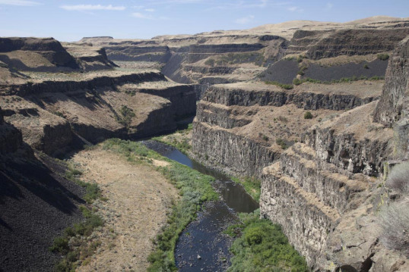
Source: Gifford, 2016

How Weathering and Erosion Shape Landscapes
The processes of weathering and erosion are characteristically independent but not exclusive when it comes to the shaping of landscapes. Working hand in hand, the two processes form and expose landscape marvels from the sinking boulders that hang up in the mountains, arches of sandstone in the arid areas, to well-caved sea cliffs standing adjacent to the river systems.
Inarguably, water is nature’s most resourceful resource. Not only is this used for domestic purposes, but this also plays an important role in influencing the shaping of landscapes (Gifford, 2016). An example of this can be illustrated by the flowing rainwater on a glacial day. The water accumulates in crevices and cracks. At night the temperatures fall and water increases in volume turning into ice thereby tearing the rock just like a sledge pound to a wedge.
The constant changes in temperature also weaken and progressively fragment rocks that enlarge when hot and shrivel when cold. In the arid regions, such pulsing gradually weathers stones into sand in the long run (Gifford, 2016). In the same way, the repeated cycles of temperature changes (from dry to wet and wet to dry) disintegrate the clay to form sand that is seen in the desert areas. To the wind processes of erosion which facilitate the shaping of landscapes, bits of the formed sand are picked up and transported by the wind that moves by blasting the sides of the adjacent rocks, polishing and buffing them smooth in the process.
Conversely, on the seashores, the action of wind waves hews onto cliffs breaking the rock materials back and forth forming the fine unique sand that is seen on seashores below the hanging cliffs. Generally, the processes of weathering and erosion influence the shaping of landscapes in many ways, but most notably they base on the processes of physical weathering that subject the rocks onto and the adjacent area where more weathering processes take place.
Conclusion
On the whole, the above explanations justify the fact that the shaping of natural landscapes is influenced by erosion. Nevertheless, erosion relies on the consequences of the weathering processes. In other words, erosion expedites landscape shaping by facilitating the subsequent processes of weathering. The process of weathering enables erosion to take place as the rock structures also influence the processes of weathering and erosion. The example of the lead-off landscape formation of a river system in figure 1 above is a photo of canyons of the meandering Green River. The landscape was shaped in the way it appears because the rocks lay flat after weathering.

References
Gifford, C. (2016) Looking at Landscapes: Weathering and Erosion. North Mankato: Smart Apple Media.

